FARNHAM PARISH COUNCIL

Chair: Mr Ian Delvallé

Clerk: Mr Peter Jarman *Councillors:*

Mill Toft *Ian Delvallé (Chair)*

Farnham Green *Petronella Humphreys*

Bishop’s Stortford *Barbara Jarman*

Hertfordshire *Rob Navara*

CM23 1HP Graham Sessions

*Chris Smith*

*Natasha Wainwright*

**Telephone: Albury (01279) 771443**

**Website:** [**www.farnham-pc.gov.uk**](http://www.farnham-pc.gov.uk)**; *Email*: clerk@farnham-pc.gov.uk**February, 2024

**News from the Parish Council**

**Planning Notices.**

3/21/0969/FUL Construction of a 50MW solar battery energy storage system facility and associated access,

(East Herts) landscaping and other infrastructure works. Land At Greens Farm, East End Stocking Pelham

Hertfordshire. ***[Awaiting Decision].***

*3/21/2845/CPO* Application to use buildings at the site of Moylan’s to process automotive waste(oil) in preparation

(East Herts) for being taken off site for recycling. Concern here is the fact that an existing waste pipe empties

in to Bourne Brook and is not identified for removal. ***[Awaiting Decision].***

UTT/23/2794/HHF Application to add single story front extension to 15 Rectory Lane with rooflight. **[Approved].**

UTT/23/2995/LB Permission requested for retention of internal alterations at 58 Hazel End Lane **[Refused].**

UTT/23/3219/HHF Permission for demolition of existing conservatory, replaced with part two story, part one-story

rear extension and first floor extension over existing kitchen for The Old Rectory, Farnham Road.

***[Awaiting Decision].***

**Highways.**

**Farnham Road** has a one-day closure (which may end up being traffic lights) on 19th February (8am-4pm) by UK Power. The **A120** between the Homebase roundabout and the M11 is due to have the final stages of completion taking place late January and early February. Details are not clear at the time of writing but there are likely to be some minor delays until it is completely open with all associated works being completed.

There are several disruptions to Farnham Road by the parcel of land on which it is proposed to build 76 residences. The closures will be related to the provision of utilities. The closures will take place intermittently over the next 18 months. Some of the time traffic lights will be in use and at other times the road will be closed and, on these occasions, warning signs should be posted in advance to warn residents. The Parish Council has made it known that in the winter period the proposed diversion (along the lane to Hazel End) may well become flooded and we would expect Farnham Road to remain open. We are also raising the issue of emergency vehicles, carers and social workers who need to access the village.

**Parish Council website and email addresses**. The government has instructed all Parish Councils to ensure that they use official website address and emails – i.e. gov.uk domain. Over the last few months this change has been taking place and from 1st February the new Parish Council website will be [**www.farnham-pc.gov.uk**](http://www.farnham-pc.gov.uk)**. Parish Councillors will also have a new email address and from this date this will be the only way to communicate parish business with councillors as they have been strongly advised to avoid using their private or personal email addresses for parish council business.** The clerk can be contacted at [**clerk@farnham-pc.gov.uk**](mailto:clerk@farnham-pc.gov.uk)**. Councillors will follow the format of first letter of first name followed by** [**surname@farnham@gov.uk**](mailto:surname@farnham@gov.uk)**; for example, the Chair (Ian Delvalle) will be** [**idelvalle@farnham-pc@gov.uk**](mailto:idelvalle@farnham-pc@gov.uk)**.** The reason for the change of email addresses follows the problems that have arisen in government recently when all personal emails had to be given to the police for an investigation as business and personal emails had not been kept secure. The change will ensure that personal and business emails are kept apart in future and this will safeguard any personal emails for councillors. Advice is expected to follow regarding What’s Ap messages. Habits may take a few weeks to change but please try to remember to use gov.uk email addresses for parish councillors as they will only communicate via official channels in future. New email addresses may be found on the new website under the heading of ‘parish council’ – ‘members’.

**Closed Circuit Television in the Village.** I am pleased to report some action in terms of moving CCTV forward after a long period of inactivity. The Headteacher of Farnham School has agreed to a camera pole being place near a school perimeter fence but it now must go to the Chelmsford Diocese for permission to be confirmed and a licence agreed. The cameras intended to be placed at Hazel End are due to be placed near to the Hazel End conservation area. It is not thought that they will cause a problem but plans have to go to a pre-application meeting by UDC Planning Department for a decision to be made before any other progress can be made. So not very much in terms of visible action sadly but some activity behind the scenes which will hopefully clarify the way forward. As we have stated previously, support from Uttlesford District Council, Essex County Council and the Police along with some very generous voluntary donations by residents in the village has provided us with £18,400 available as funding and we have negotiated with our preferred company to provide and install the system. Should any person wish to discuss the plans they are welcome to contact the Clerk of the Parish Council. In summary, progress is very slow!

**As there will be incidental extras, if any residents still wish to donate, they are welcome to contact Peter Jarman in confidence to discuss their wishes or donate via the internet to our bank account as below:**

**Account: Farnham Parish Council; Sort Code: 30-90-84; Account No: 00219534; Reference: CCTV**

**BT – Information on BT Digital Voice and Conversion of Land Lines.** Following on from the section on BT Digital Voice in the previous edition, I am now aware that the process has been paused again due to problems in rural areas and difficulties encountered with medical and house alarm system. This is not being well-covered in the press so hopefully this will change in the future.

*The next meetings of the Parish Council will take place at 8pm on Monday 19th February 2024 and then the Annual Meeting of the Parish on Monday 18th 2024. Members of the public are welcome to attend Parish Council meetings and notices and agendas are always published in advance on the village notice boards (outside of Home Farm, Hazel End; outside of ‘Thrifts Farm’, Farnham Green, outside of the Village Hall) and the Parish Council website. Occasionally meetings may be held on Zoom and if this is the case links can be requested from Chris Smith. There is also a public participation item when questions relating to past or present business may be asked.*

*Peter Jarman*

**Village Diary**

**Events This Month:**

Tuesday 13th February Walking Group 10am start from Thrifts Farm – Ring 771313

Monday 19th February Parish Council Meeting 8pm Village Hall – All Welcome

Tuesday 27th February Walking Group 10am start from Thrifts Farm – Ring 771313

Wednesday 28th February Coffee & Cake 10am-12 Farnham Church

**Forthcoming Events:**

Monday 18th March Annual Meeting of the Parish 7.30 for 8pm Village Hall. All welcome.

Refreshments at 7.30pm & at end of meeting.

Saturday 23rd March Village Hall Quiz 7pm Village Hall (details to follow)

Wednesday 27th March Coffee & Cake 10am-12 Farnham Church

**Regular activities:**

Wednesdays Coffee & Cake 10am-12 Farnham Church (last Weds of month)

Except December

Yoga 6.30-7.45pm School Sports Hall

Breathing Course 1.30pm & 5.30pm each for 20 minutes email [jwilson.theglobe@btinternet.com](mailto:jwilson.theglobe@btinternet.com)

Thursdays Zoom Yoga 7am (Contact Jo for Zoom link}

Zoom Yoga 9am (Contact Jo for Zoom link)

Toddlers’ Group9am–11am School Hall *(term time only)* Ring 77600*4*

***Carols Around the Christmas Tree***

Christmas Eve was celebrated by just over eighty people

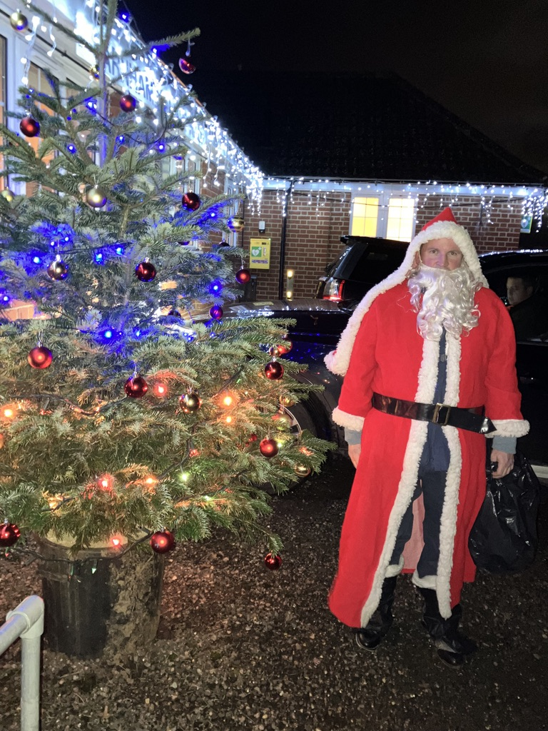

enthusiastically singing carols. The evening began with a few carols

around the Christmas tree outside the village hall. Then everybody

came back into the hall to sing more carols led by the Rev. Colin,

often giving children the choice of the next carol and adding his own

personal touch of enthusiasm to the evening.

The singing was helped along by a constant supply of sausage rolls, mince

pies and mini pizzas along with warm mulled wine or hot chocolate to help

lubricate the voices. The mince pies and sausage rolls had been donated

by several people in the village and David Arnold had made and donated the

the mini-pizzas. There was also the opportunity to relax and enjoy some

early Christmas spirit at the bar.

Towards the end of the carol singing there was a surprise visit from Father Christmas! He was given a warm welcome as he entered the village hall and was soon surrounded by several children who weren’t quite sure what to believe. Their shock was soon overcome when Santa opened his sack and gave every child present. Having distributed his gifts he left,

wishing everybody ‘Merry Christmas’.

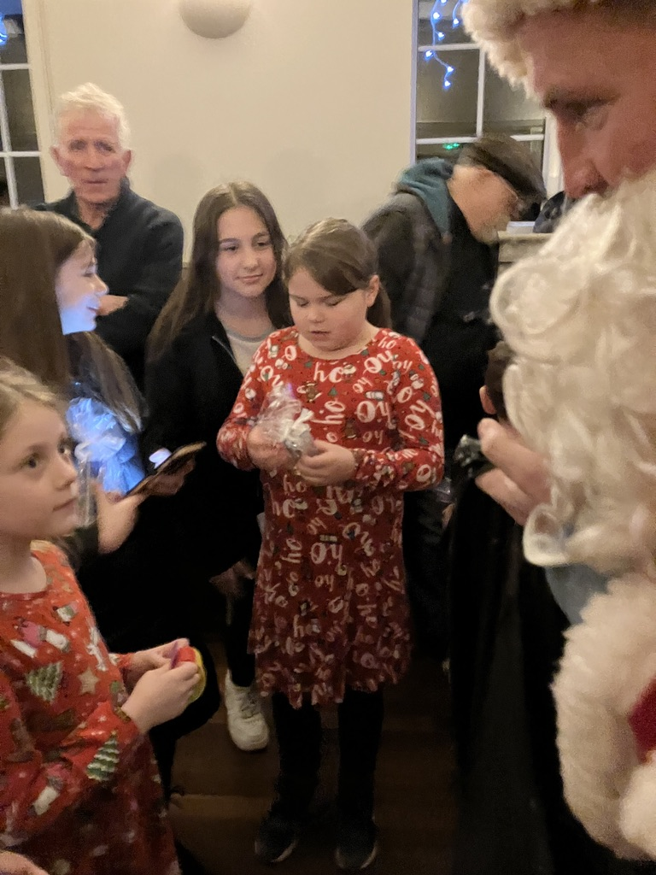

We were very grateful to Father Christmas for his surprise

visit at such a busy time for him.

It was good to see the informal evening so well-supported

by everybody.

Donations were made towards to upkeep of the Recreation

area and were very much appreciated.

The members of the Parish Council Recreation Committee

*(Lea Fraser-Andrews, Liz Hitchman, Barbara Jarman, Lesley*

*Pearson, Emma Smith and Peter Jarman)* would like to thank

everybody for supporting the evening and look forward to

seeing you all on Christmas Eve 2024.

